FODS ASSIGNMENT 8

Name – Atharva Shivaji Dabkekar
Roll no. – 2090138
PRN - 1251090357
Division – S.Y A
Batch – 2
DATE – 21-08-2026 TIME – 8:00 TO 10:00
Practical 8: Singly Linked List
Implement a Singly Linked List using dynamic memory allocation. Perform insertion, deletion, traversal, searching, sorting, and concatenation operations.
Answer:
- Insertion:
Code:
#include <iostream>
using namespace std;

struct Node
{
int data;
Node *next;
};

Node *head = NULL;

void insertAtBeginning()
{
int value;

cout << "Enter value: ";
cin >> value;

Node *newNode = new Node;

newNode->data = value;
newNode->next = head;
head = newNode;

cout << "Node inserted at beginning.\n";
}

void insertAtEnd()
{
int value;

cout << "Enter value: ";
cin >> value;

Node *newNode = new Node;

newNode->data = value;
newNode->next = NULL;

if (head == NULL)
{
head = newNode;
}
else
{
Node *temp = head;

while (temp->next != NULL)
{
temp = temp->next;
}

temp->next = newNode;
}

cout << "Node inserted at end.\n";
}

void insertAtPosition()
{
int value, position;

cout << "Enter value: ";
cin >> value;

cout << "Enter position: ";
cin >> position;

if (position <= 0)
{
cout << "Invalid position.\n";
return;
}

if (position == 1)
{
insertAtBeginning();
return;
}

Node *temp = head;

for (int i = 1; i < position - 1 && temp != NULL; i++)
{
temp = temp->next;
}
if (temp == NULL)
{
cout << "Invalid position.\n";
return;
}
Node *newNode = new Node;

newNode->data = value;
newNode->next = temp->next;
temp->next = newNode;

cout << "Node inserted at position "
<< position << ".\n";
}
void insertion()
{
int choice;

cout << "\n===== INSERTION =====\n";
cout << "1. Insert at Beginning\n";
cout << "2. Insert at End\n";
cout << "3. Insert at Specific Position\n";
cout << "Enter your choice: ";
cin >> choice;

switch (choice)
{
case 1:
insertAtBeginning();
break;

case 2:
insertAtEnd();
break;

case 3:
insertAtPosition();
break;

default:
cout << "Invalid choice.\n";
}
}
void display()
{
Node *temp = head;

cout << "\nLinked List: ";

while (temp != NULL)
{
cout << temp->data << " -> ";
temp = temp->next;
}
cout << "NULL\n";
}

int main()
{
int choice;
do
{
insertion();

cout << "\nDo you want to insert again?\n";
cout << "1. Yes\n";
cout << "2. No\n";
cout << "Enter choice: ";
cin >> choice;

} while (choice == 1);

display();

return 0;
}

  - Insertion at beginning
CODE:
void insertAtBeginning()
{
int value;
cout << "Enter value: ";
cin >> value;
Node *newNode = new Node;
newNode->data = value;
newNode->next = head;
head = newNode;
cout << "Node inserted at beginning.\n";
}
OUTPUT: 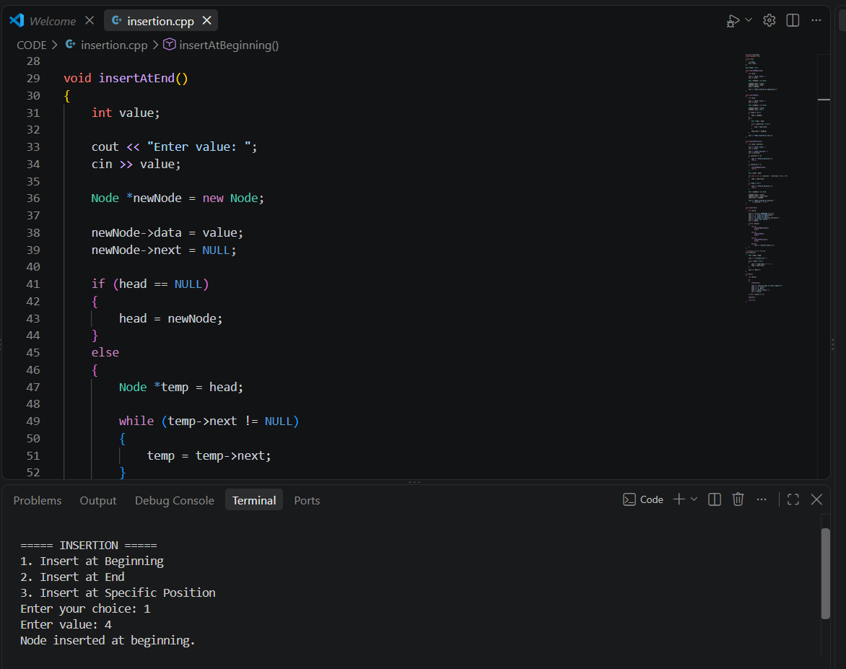
  - Insertion at end
CODE:
void insertAtEnd()
{
int value;

cout << "Enter value: ";
cin >> value;

Node *newNode = new Node;

newNode->data = value;
newNode->next = NULL;

if (head == NULL)
{
head = newNode;
}
else
{
Node *temp = head;

while (temp->next != NULL)
{
temp = temp->next;
}

temp->next = newNode;
}

cout << "Node inserted at end.\n";
}

OUTPUT: 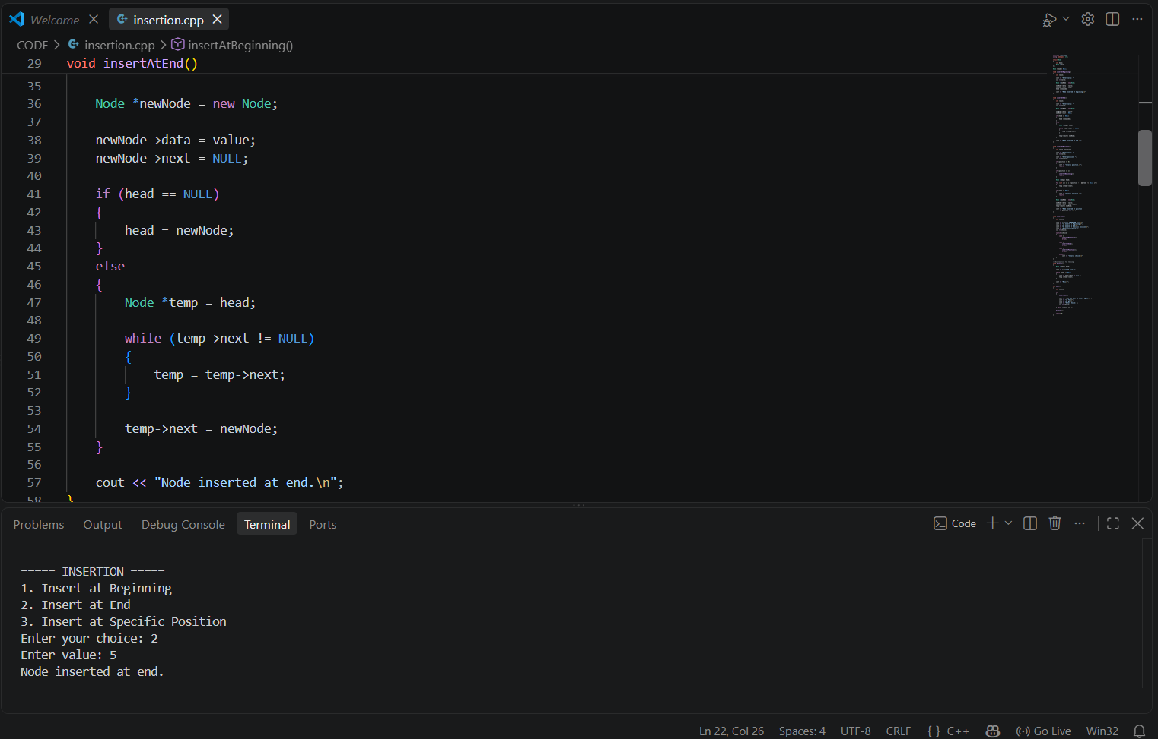
  - Insertion in between
Code:
void insertAtPosition()
{
int value, position;
cout << "Enter value: ";
cin >> value;
cout << "Enter position: ";
cin >> position;
if (position <= 0)
{
cout << "Invalid position.\n";
return;
}

if (position == 1)
{
insertAtBeginning();
return;
}

Node *temp = head;

for (int i = 1; i < position - 1 && temp != NULL; i++)
{
temp = temp->next;
}

if (temp == NULL)
{
cout << "Invalid position.\n";
return;
}

Node *newNode = new Node;

newNode->data = value;
newNode->next = temp->next;
temp->next = newNode;

cout << "Node inserted at position "
<< position << ".\n";
}

Output:
- Deletion:
  - Deletion at beginning
  - Deletion at end
  - Deletion

